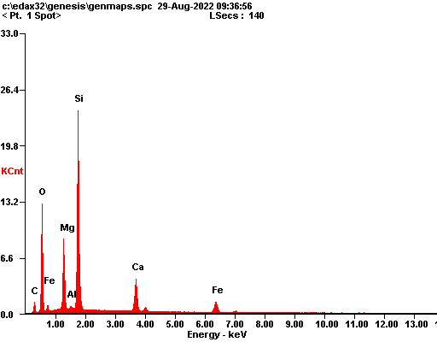

|  |  |  |
| --- | --- | --- |
| ***Element*** | ***Wt%*** | ***At%*** |
| ***CK*** | 06.79 | 12.98 |
| ***OK*** | 28.27 | 40.54 |
| ***MgK*** | 10.64 | 10.05 |
| ***AlK*** | 00.33 | 00.28 |
| ***SiK*** | 30.18 | 24.66 |
| ***CaK*** | 10.64 | 06.09 |
| ***FeK*** | 13.14 | 05.40 |
| ***Matrix*** | Correction | ZAF |

